Technical Analyst -TA
Technical analyst - Preparing the financial documents for the agent while attending for hearing Schedule commercial accounts.
We will receive the financials email request from Denise or Houston commercial agents and the email contains attachments of property details as follows.
Also, we will receive the documents from HOUSTON scanning department via Paperwise IN Batch codes.
Types of Financials Documents:
- Financials Rent Roll
- Financials Income & Expenses
- Partial RR (Rent Roll)
- Partial IE (Income Expenses)
- Handwritten RR
- Handwritten IE
- Federal tax IE
- Client Notes
- Deed
- Closing Statements.
- Photos
- Property Estimates and renovated invoices from the vendors
- Business personal property letters.
These documents will be scanned to paperwise via sendto option in paperwise by the user with TA batch codes and user will index the document with the respective account number in paperwise.
Also, the attached documents will be pasted into OCA agent Drop box folder for accessing the document by the commercial hearing agents. Since, these financial documents are needed for commercial properties to present in hearing files.
Financials Rent Roll
Financials Rent Rolls documents are having the rent rates for the commercial property from January to December or up to middle of the month.
The below screenshot for the example of Full RR (Rent roll)
Full RR contains the below information,
- Unit
- Tenant Name
- Square feet
- Start Date and End Date
- Amount
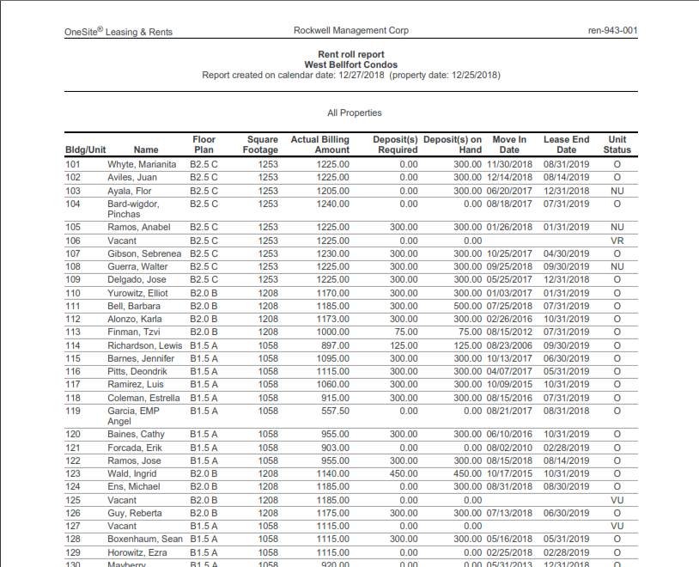

Financials Income & Expenses
Financials Income & Expenses documents are having the Income for the commercial property and Expenses from January to December or up to middle of the month.
The below screenshot for the example of Full IE (Income & Expense)
Full IE contains the below information,
- Income
- Operating Expenses
- Utility
- Insurance
- Maintenances
- Amounts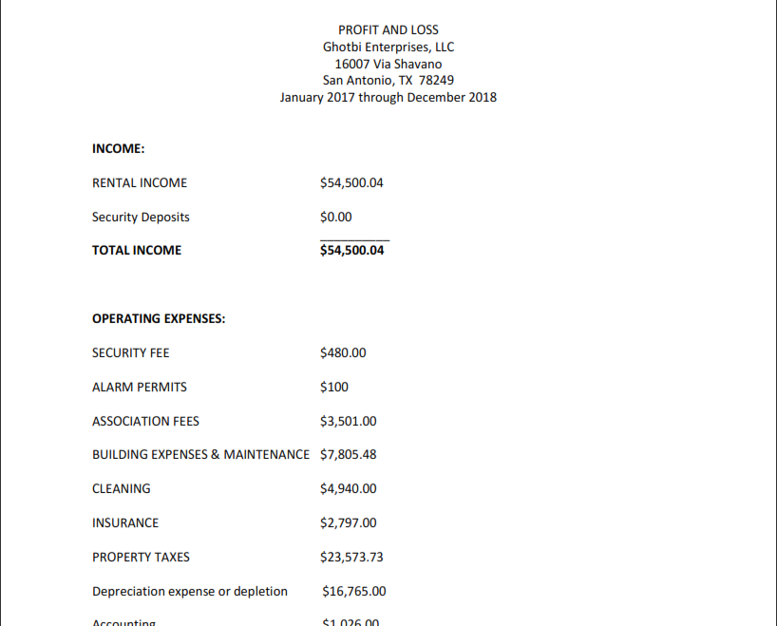
Partial RR (Rent Roll)
Financials Rent Rolls documents are having the rent rates for the commercial property from January to middle of the month.
The below screenshot for the example of Partial RR (Rent roll)
Full RR contains the below information,
- Unit
- Tenant Name
- Square feet
- Start Date and End Date
- Amount
Also, we will received above any info missing documents are consider as Partial RR
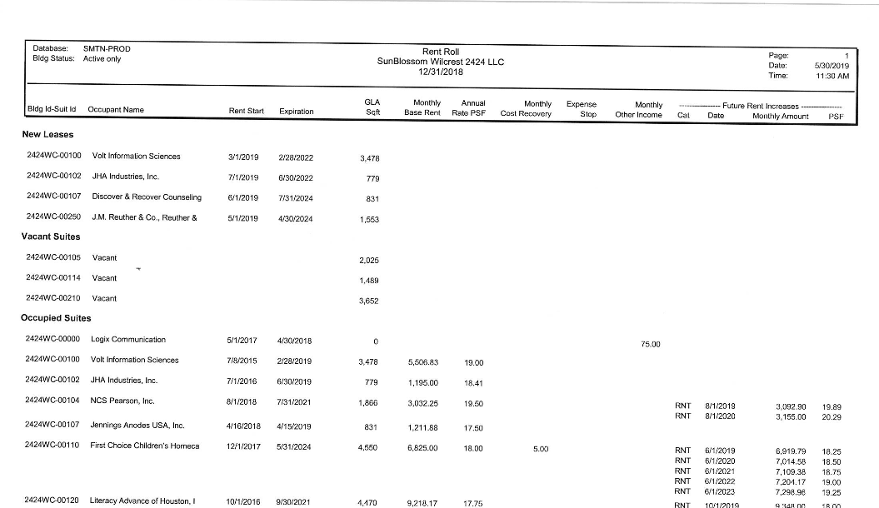

Partial IE (Income & Expenses)
Financials Income & Expenses documents are having the Income for the commercial property and Expenses from January to middle of the month.
The below screenshot for the example of Partial IE (Income & Expense)
Full IE contains the below information,
- Income
- Operating Expenses
- Utility
- Insurance
- Maintenances
- Amounts
Also, we will received above any info missing documents are consider as Partial IE

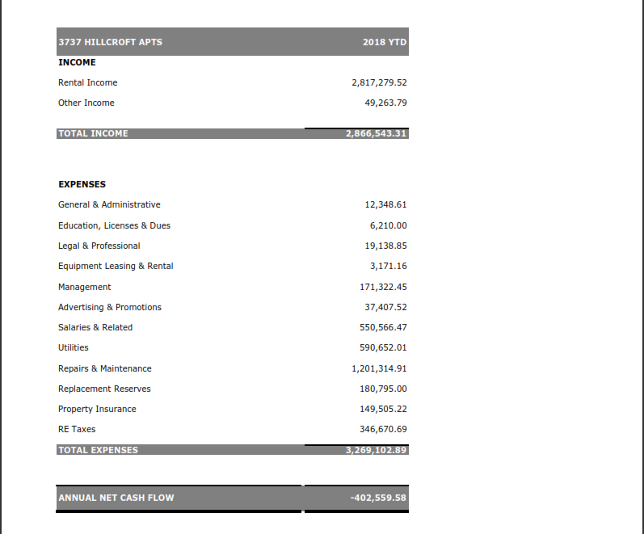

Handwritten RR
Financials handwritten RR documents having handwritten Rent Rate information as like printed in Rent Roll by the property owner filled format.
Handwritten IE
Financials handwritten IE documents having handwritten Income & Expense information as like printed in Income & Expense by the property owner filled format.
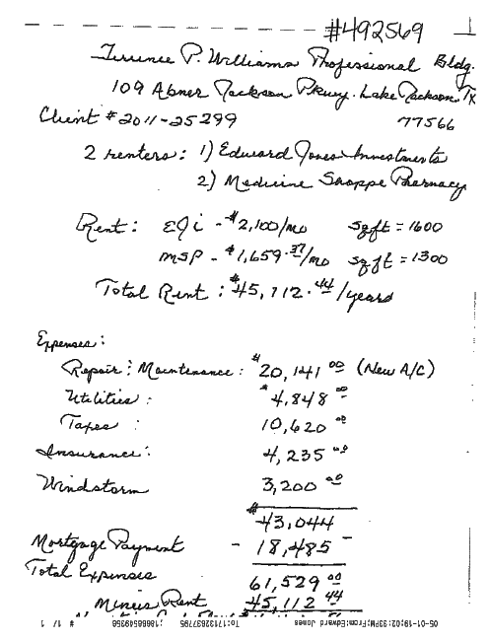
Searching Account number in Spartaxx Main screen:-

User need to find the account or project which is mentioned in the document by using in main screen search option tab in spartaxx.
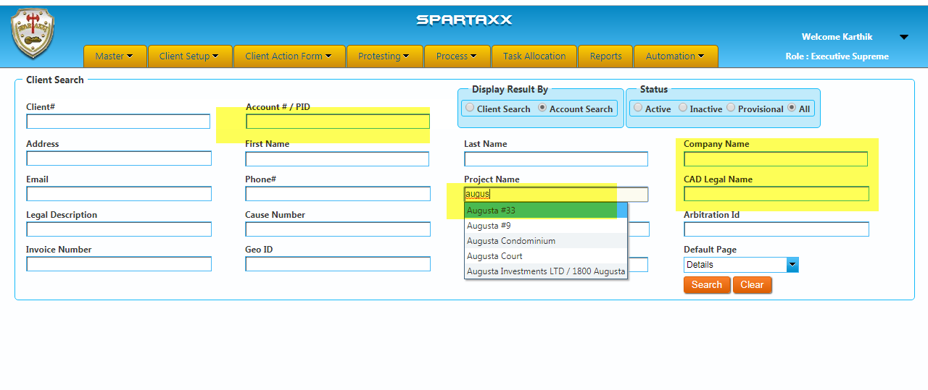
Process flow in spartaxx and paperwise:-
We will receive the financials documents through the email in pdf or image format. However, we will change the format to pdf for uploading into paperwise.
We need to send the PDF documents to paperwise through sendto option in paperwise. 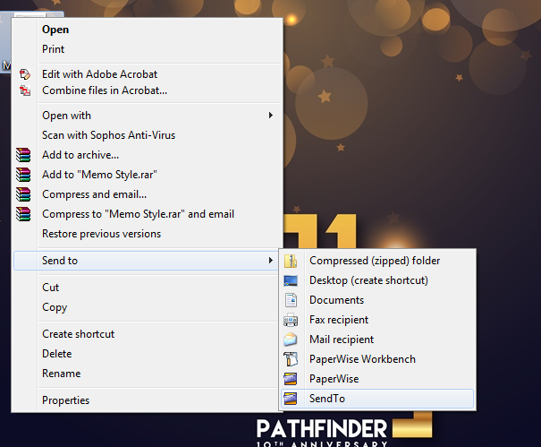
Thus, in Sendto we should create the batch code as “TA-mmddyy-Emp-id”.
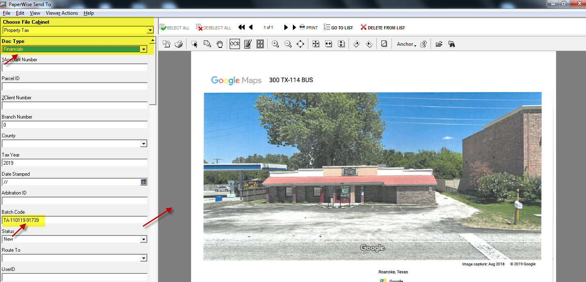

Once, uploaded in respective batch code user should index the document with respective accounts and route the document to New ITA queue in paperwise.
If the project has multiple account numbers user should duplicate the same document for all the accounts in particular project.
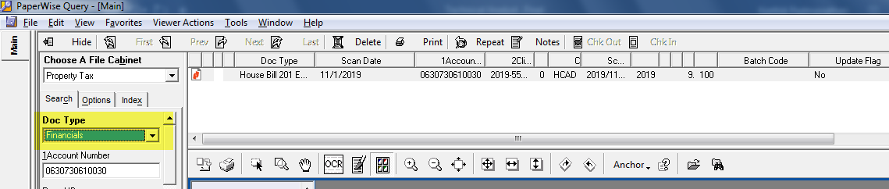

ITA Queue agents will do spartaxx Entry and tract which document received status in spartaxx main screen financials tab with user signature like PFTA/RK.
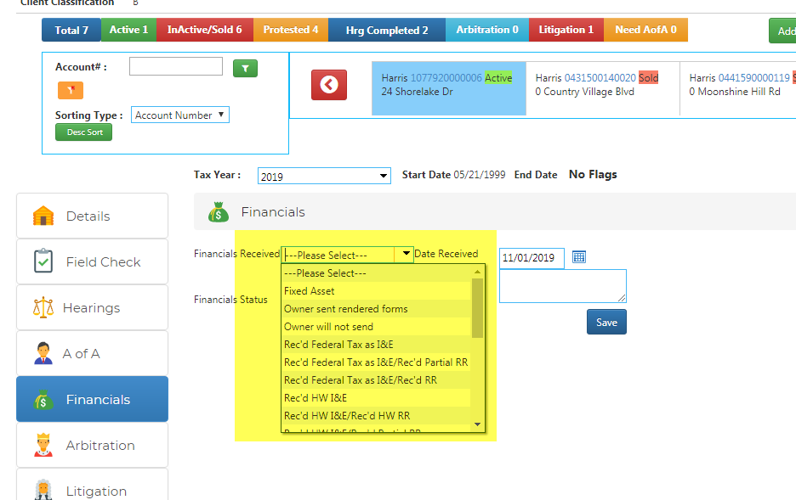
After entry done in spartaxx, user route the document to New ITA Audit queue and Audit user will do audit whether the entry has entered correct or not.
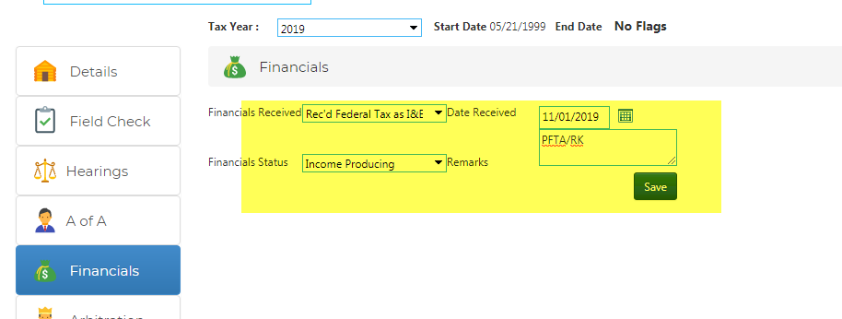
The audit user can make any changes in the main screen financials tab if at all entry is wrong and route the document to complete in paperwise.
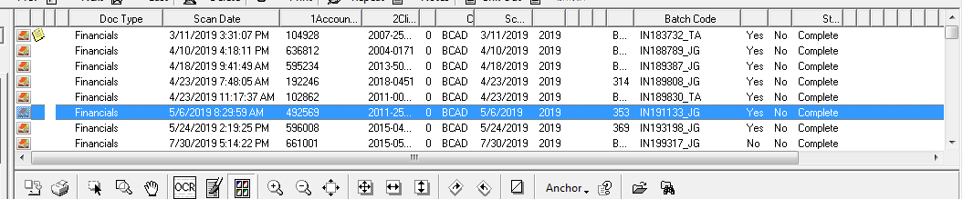
OCA Drop box Pasting:-
The audit user should paste the email received documents to the under below path with mentioned format.
Path:-
\\475044-db1\Client_Financials
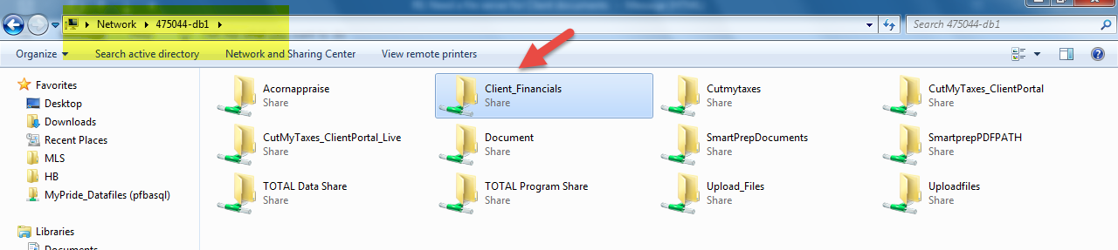
Format:-
- 2019
- County
- Account Number
- Financials

Also, audit user should paste the email received document to below path by searching the account number and find commercial agent dropbox.
\\pfbasamtl10\Dropbox (OCA_Commercial)\OCA_Commercial Team Folder\2019

Business personal Property letter:-
We will receive the document for personal property accounts as like in the below screen shot. User should only do index and route the document to complete blank.
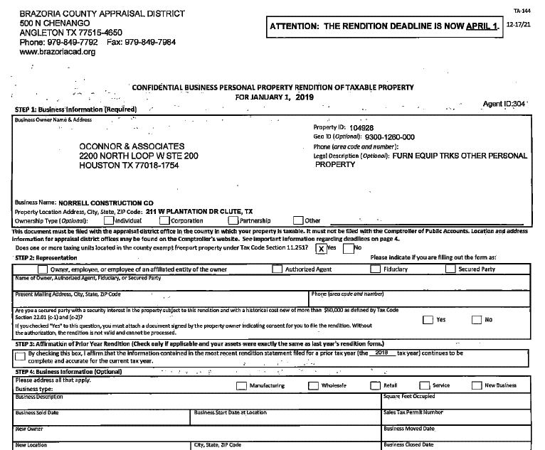

In this document, is there any Penalty Waiver has mentioned which should be forwarded to Denise and Brittany for further proceedings.
Property Extension letter:-
We will receive the document for personal property accounts as like in the below screen shot. User should only do index and route the document to complete blank.
